Trader Sentiment Report
Trade-level performance was grouped by market sentiment and compared across five categories: Extreme Fear, Fear, Neutral, Greed, and Extreme Greed.

Data Notes
This analysis covers 104,402 closing trades (from 211,218 total execution records) across 32 unique accounts, merged with daily Bitcoin Fear & Greed Index classifications. The historical trade data included fields such as execution price, size, side, direction, closed PnL, and fees, but did not include a leverage field, so leverage-adjusted performance could not be assessed in this analysis.

Win Rate and Profitability by Sentiment
Sentiment | Trades | Win Rate | Avg PnL/Trade | Total PnL
Extreme Fear | 10,406 | 76.2% | $71.03 | $739,110
Fear | 29,808 | 87.3% | $112.63 | $3,357,155
Neutral | 18,159 | 82.4% | $71.20 | $1,292,921
Greed | 25,176 | 76.9% | $85.40 | $2,150,129
Extreme Greed | 20,853 | 89.2% | $130.21 | $2,715,171
Win rate and average profit per trade do not move in a straight line from Fear toward Greed. Instead, they form a U-shape: the two sentiment extremes, Fear (87.3% win rate, $112.63 average profit per trade) and Extreme Greed (89.2%, $130.21), clearly outperform the calmer middle of the spectrum. Extreme Fear is the weakest regime observed, with the lowest win rate (76.2%) and one of the lowest average profits ($71.03) per trade.

Profitability Chart
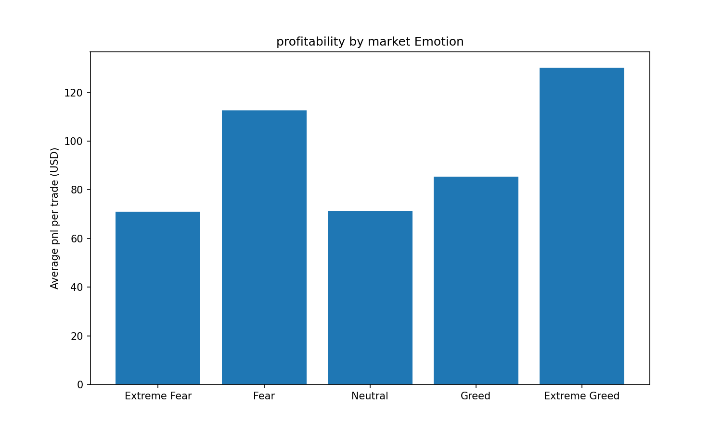

Statistical Significance
A Welch's t-test comparing per-trade profit between the Fear-family group (Fear + Extreme Fear) and the Greed-family group (Greed + Extreme Greed) produced t = -0.403, p = 0.6873. Since this p-value is well above the standard 0.05 significance threshold, the broad Fear-vs-Greed split does not show a statistically significant difference in average trade profitability.
However, a direct comparison of the two sentiment extremes tells a different story: Extreme Fear versus Extreme Greed produced t = -3.369, p = 0.0008. This result is statistically significant, confirming that the U-shaped pattern is real at the extremes even though it is not visible when Fear/Extreme Fear and Greed/Extreme Greed are grouped together as broad categories. This is the result that actually supports the Key Takeaway below.

Key Takeaway
Traders in this dataset performed best during periods of strong sentiment in either direction (Fear or Extreme Greed), and worst during Extreme Fear. This suggests that sentiment intensity, rather than sentiment direction alone, is the more useful signal for anticipating trading performance.

